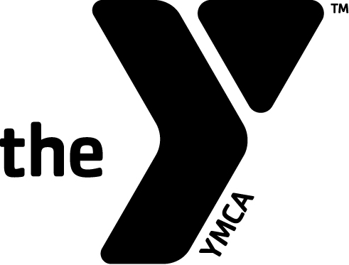

YMCA CAMP MANITOU-LIN

GENERAL LIABILITY RELEASE

GENERAL LIABILITY:
I understand that the YMCA of Greater Grand Rapids assumes no responsibility for injuries, which I or my child may sustain as a result of my or my child’s physical condition or resulting from my or my child’s participation in any activities, programs, exercise, or the use of any facility, equipment, or other activities organized or sponsored by the YMCA of Greater Grand Rapids & Affiliates. I expressly acknowledge that I assume risk for any and all injuries and illnesses that may result. In consideration of the privilege of joining, or using the YMCA, I hereby voluntarily release and discharge the YMCA of Greater Grand Rapids, its agents, servants, and employees from any and all claims for injury, death, loss or damage that I or my child may suffer. I understand the YMCA of Greater Grand Rapids is NOT responsible for personal property lost or stolen while members and/or program participants are using YMCA facilities or on YMCA premises.

PHOTO RELEASE:
We love taking pictures of our guest enjoying their time at Camp Manitou-Lin. We often use these photos in our marketing and promotional efforts. By signing this waiver, you agree to give the YMCA of Greater Grand Rapids permission to use any media of me or my child at camp for purposes of promoting or interpreting YMCA Programs. If you’d prefer your photo not be used, please let us know in writing prior to your camp experience.

Name of Participant _____________________________________________________Date of Birth________________

Signature ________________________________________________________________ Date ____________________
Self/Parent/Guardian (circle appropriate title)

Address___________________________________City____________________State________Zip Code____________

Email Address_____________________________________________________________________________________

Phone: ___________________________________________________________________________

EMERGENCY AUTHORIZATION

I hereby give permission to the medical personnel selected by the camp director to provide routine health care; to administer medications; to order X-rays, routine tests, treatment; to release any records necessary for insurance purposes; and to provide or arrange necessary related transportation for myself or my child. In the event that I cannot be reached in an emergency, I hereby give permission to the physician selected by the camp director to secure and administer treatment, including hospitalization, for the named person above.

Signature _________________________________________________ Date _______________________
Self/Parent/Guardian (circle appropriate title)

